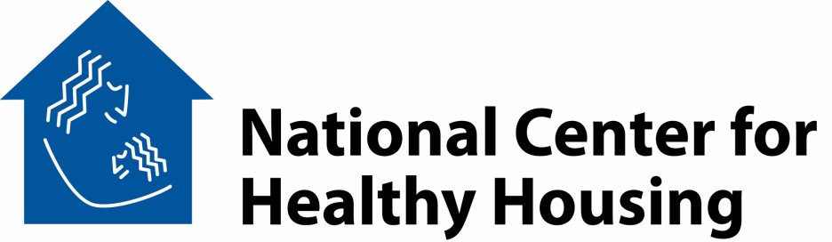

Code Inspection for Healthier Homes
Agenda
Duration Topic
5 min Welcome / Course Overview
30 min Making the Connection Between Health and Housing
- Institute of Medicine Reports on Asthma and on Dampness
- Group Exercise
20 min American Housing Survey – Snapshots of the Problem
- Trends – 2005 to 2007
- Metropolitan Statistical Areas – Comparison to National
- Interior-Exterior Relationships
20 min Property Maintenance Codes and Health
- State Codes
- Local Codes
- International Property Maintenance Code
15 min Break
20 min Code Enforcement Strategies
- Complaint-Based Inspection
- Systematic Inspection
- Certificate of Occupancy
- Education and Accountability
15 min Landlord-Tenant Law
40 min Handling Special Issues
- Pests and Pesticides
- Mold and Dampness
- Lead and Deteriorated Paint
- Radon and Asbestos
10 min Wrap-up and Review
Adjourn

Building a healthy home environment for all children
10320 Little Patuxent Parkway, Suite 500, Columbia, Maryland 21044 410.992.0712 FAX 443.539.4150
www.centerforhealthyhousing.org

